**Mission 4:**

**Remix**

**Student Workbook**



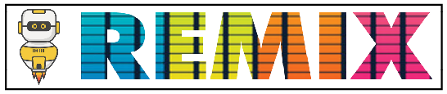

**Ready to go!**

This assignment will let you be creative and come up with your own program for the   
CodeX to run.



Go to the Mission 4 Remix Log and fill out the Pre-Remix preparation.



**Time for a project remix**

A remix can be:

* A new program created by adding new code to a program you already created
* You can combine parts of two or more programs in a remix
* Use a similar idea in a different way

**Creating a remix will let you:**

* Master the skills and concepts practiced in the mission
* Be creative
* Remember code from earlier programs and missions
* Work with your peers
* Design an original program and write the code all on your own

**Step #1: Review the mission**

* Review your programs from Mission 2, 3 and 4
  + What do the programs do?
  + What skills were used or concepts learned?

**DO THIS:**

* Open your project from Mission 4 - Display
* Review what the program does
* Review the programming concepts and skills you learned
* Fill out the information in the remix log

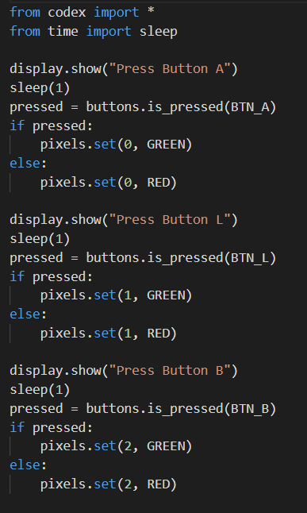

**Step #2: Brainstorm ideas**

Read through remix suggestions

* + Three ideas are on the next pages. You can use one of these ideas or come up with your own.
* Use your creativity to come up with your own idea for a project
* Decide with your partner what project you will do



**Mild Remix**

Add images to the code. When a pixel turns green, display an image like a happy face. When a pixel turns red, display a different image, like a sad face.

[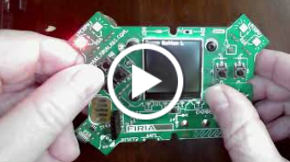](https://www.youtube.com/watch?v=ouMo9ANyXOg)

[Video of Mild Remix](https://youtu.be/ouMo9ANyXOg?si=xxU2JOs6FDRU5bfK)



**Medium Remix**

Use images instead of printed instructions. There are arrow images available. Display an arrow and check for the correct button. For example, the north arrow goes with BTN_U. [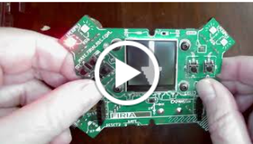](https://www.youtube.com/watch?v=BJ_MTiSCsMI)

[Video of Medium Remix](https://youtu.be/BJ_MTiSCsMI)



**Spicy Remix**

Use a color of pixel to indicate which button to press. For example, if a pixel turns red, press BTN_U. If a pixel turns blue, press BTN_D. And so forth. You could use six colors and all six buttons. Display one image (like the happy face) if they choose correctly and a different image (like a sad face) if they are wrong. You may want to include a set of print statements at the beginning that tell the button and color combination.[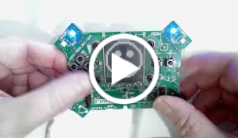](https://www.youtube.com/watch?v=6NyreUBo3rY)

[Video of Spicy Remix](https://youtu.be/6NyreUBo3rY)

**DO THIS:**

* Decide with your partner what project you   
   will do
* Fill out the information in the Mission 4 Remix   
   Log for **Step #2**

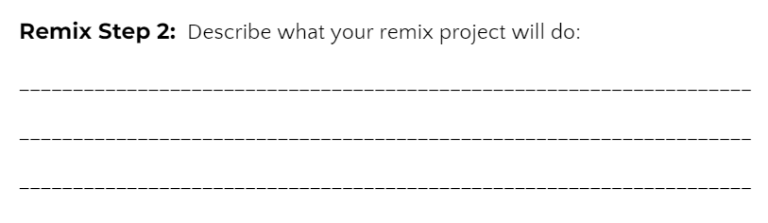

**Step #3: Make a plan**

Now that you have an idea for your remix, you need a plan.

* What variables will you need?
  + NOTE: You do not have to use a variable for this remix
* What colors will you use?
* What images will you display?



**DO THIS:**

* Fill out the information in the Mission 4 Remix   
  Log for **Step #3**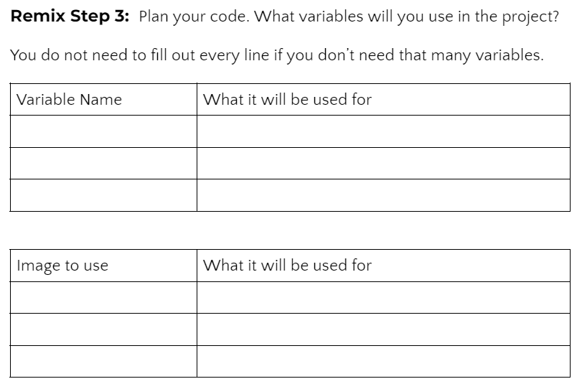

**Step #4: Code your project**

* **IMPORTANT:** In CodeSpace, go to the sandbox:  It is above the toolbox in the lower left corner.
* You can leave **Display** open (use it as a guide)



**DO THIS:**

* Start with a new file and give it a descriptive   
   name (**Remix4**)
* Import your modules
* Define your variables
* Write your code, testing frequently

**Reminders!**

* Don’t try to write all the code at one time
* Mistakes happen, so find them early
* Type just a few lines of code and then run the program
* If there is an error, fix it before continuing
* Use the debugger and your other programs for help

**Step #5: Documentation**

You should always make your code readable and easy to follow.



**DO THIS:**

* + - * Add blank lines where needed to divide sections of code
      * Add a comment at the top with your name and the name of the program
      * Add a few more comments to sections of your code that explain what they do

**Step #5: Get feedback**

Getting feedback and reflecting on your code can help you make the program even better.



**DO THIS:**

* Show your code to another student
* Have him/her fill out the feedback form on your   
  Mission 4 Remix Log
* Give yourself some feedback
* Is there something you want to change or   
  improve or add?
* Fill out the feedback form on your Mission 4   
  Remix Log

**Modify your code to make your project even better**

**Congratulations!**

Now you have your own remix!   
Great job! Share your project with   
your friends.

By completing this remix you have:

* learned more about programming
* used skills and concepts from the missions
* been thinking!
* and problem solving
* and much more!
* 

**DO THIS:**

* Complete the Mission 4 Remix Log
* Don’t forget to clear your CodeX by   
  running your **Clear** program